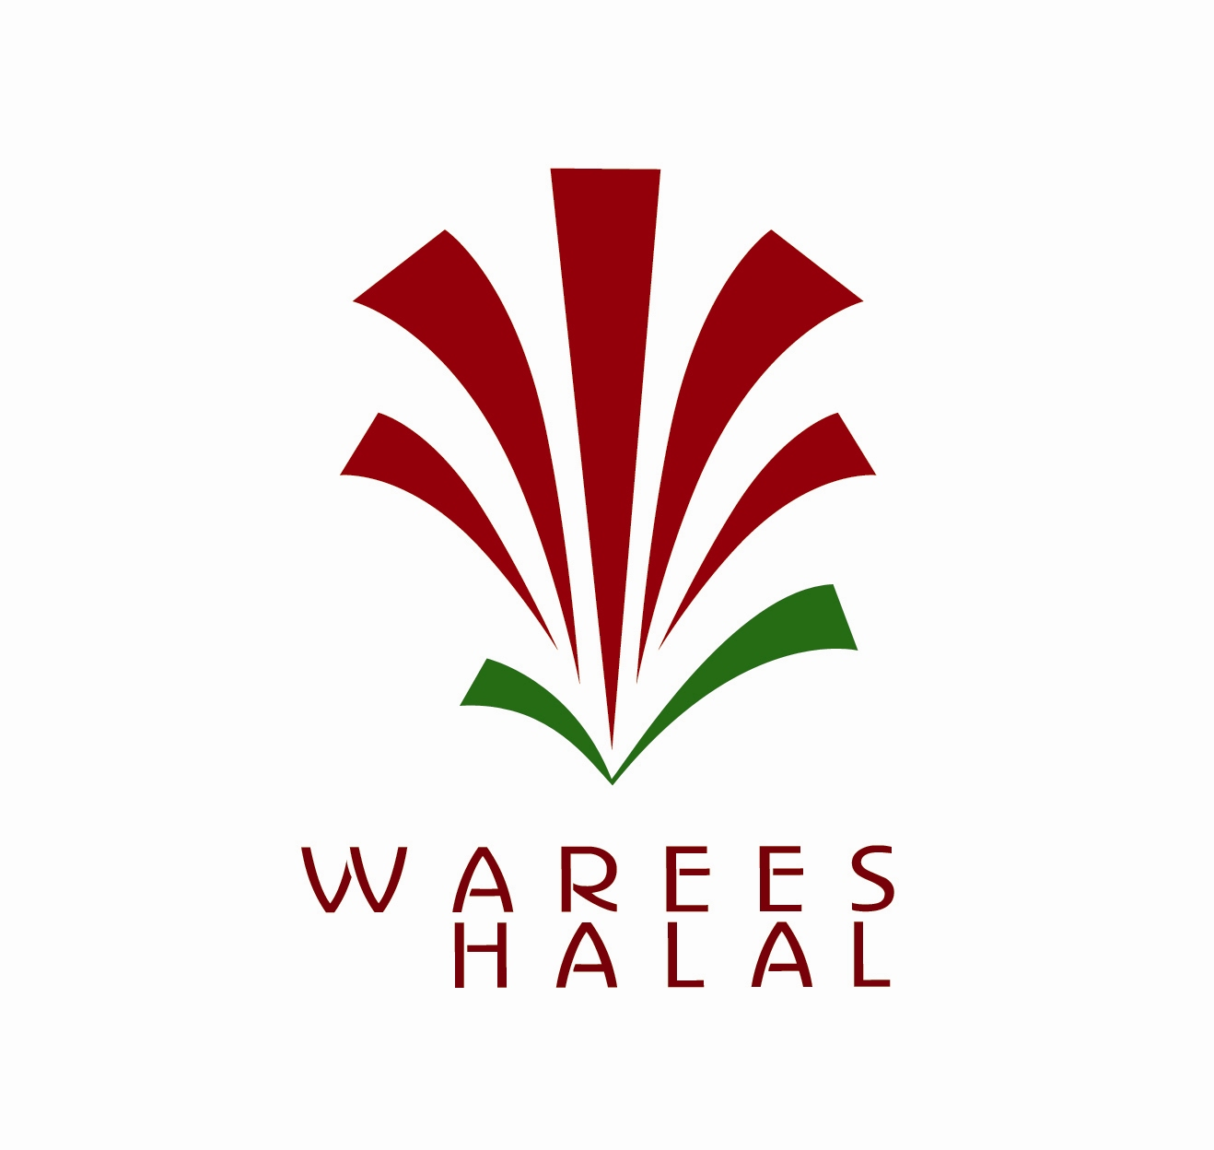

ALL APPLICATIONS ARE TREATED
IN STRICT CONFIDENCE
Application to
Singapore International Halal Certification
based on
Singapore Halal Quality Mngt System (HALMQ)

This document is provided for the application to Warees Halal ,
a division of Warees Investments Pte Ltd,
a wholly –owned subsidiary of the Islamic Religious Council of S’pore (Muis)

APPLICATION PROCEDURE

ENQUIRY

- Enquiry with halal certification specialist
- Brief on international halal certification based on HALMQ

SUBMISSION

- Submission of application form
- Assessment of application
- Brief on halal certification project & quote

IMPLEMENTATION

- Development & implementation of HALMQ
- Audit on documentation and physical premise

CERTIFICATION

- Issuance of halal certificates upon successful audit (1 year validity)

POST-CERTIFICATION

- Periodic surveillance audit
- Processing of additional applications

RENEWAL

- Issuance of reminder letter for renewal of halal certificates
- Processing of renewal applications
- Issuance of renewed halal certificates (1 year validity)

APPLICATION DETAILS PLEASE FILL IN ALL INFORMATION IN ENGLISH & CHINESE LANGUAGES

PARTICULARS OF APPLICANT

Organisation Name:

Organisation Address (Postal Adress):

Organisation Telephone: | Organisation Fax:
Corporate Website: | Corporate Email:
Contact Person Name: | Contact Person Designation:
Contact Person Tel/Fax: | Contact Person Email:

PARTICULARS OF MANUFACTURING FACILITY

Manufacturing Facility Name:

Manufacturing Facility Address (Postal Adress):

Manufacturing Facility is HACCP Certifed:
Yes No

Manufacturing Facility Telephone: | Manufacturing Facility Fax:
Corporate Website: | Corporate Email:
Contact Person Name: | Contact Person Designation:
Contact Person Tel/Fax: | Contact Person Email:

LIST OF PRODUCTS FOR HALAL CERTIFICATION

No. | Brand Name | Product Name | Official Use
1 | (example)  “Hippy Brand” | (example)  Strawberry Chocolate (500 grams)
2

3

4

5

6

7

8

9

10

11

12

13

14

15

* Add a separate sheet of information if there are more than 15 products for halal certification

DETAILS OF INGREDIENT LISTS – PRODUCTS FOR HALAL CERTIFICATION

REFER TO INGREDIENT LISTS APPLICATION FORM AVAILABLE IN EXCEL FORMAT

FACTORY MANUFACTURING PROCESS FLOW

Step 1  MATERIAL SUCTION (example) | Step 11
Step 2  VACUUM MIXING (example) | Step 12
Step 3  PASTEURAZIATION (example) | Step 13
Step 4  FILLING & SEALING (example) | Step 14
Step 5  PASTEURAZIATION & COOLING (example) | Step 15
Step 6 | Step 16
Step 7 | Step 17
Step 8 | Step 18
Step 9 | Step 19
Step 10 | Step 20
* Add a separate sheet of information if there are more than 20 steps for halal certification

LIST OF PRODUCTS MANUFACTURED IN THE FACTORY

Product 1 | Product 11
Product 2 | Product 12
Product 3 | Product 13
Product 4 | Product 14
Product 5 | Product 15
Product 6 | Product 16
Product 7 | Product 17
Product 8 | Product 18
Product 9 | Product 19
Product 10 | Product 20
* Add a separate sheet of information if there are more than 20 products manufactured in the factory

DECLARATION BY APPLICANT

I/We hereby declare that all the above information supplied by me/us, to the best of my knowledge and belief, are true and that I have not willfully suppressed any material facts which is requested for in this application. Any false declaration will be subjected to my/our application being cancelled/rejected.

____________________ ____________________ ____________________
Name Designation Date

____________________ ____________________
Company Name Company Stamp

